Science Fair 2021 Lab Report

A. TITLE: The Effect of Different Brands, SPFs, Types of Sunscreens, and the Amount of Sunscreen on how well They Protect Against UV Light

B. BACKGROUND RESEARCH/PURPOSE

Background Research Questions/Topics:

- What does sunscreen do?/What is the purpose of sunscreen?

Sunscreen protects the skin from harmful UV radiation, and minimizes the chances for severe sunburns, skin cancer, and various skin disorders.

- What is SPF and how does it affect the sunscreen?

SPF stands for sun protection factor, and is a measure of how much solar energy it will take to penetrate the skin and cause sunburn with sunscreen in comparison to how much solar energy it will take when fully exposed. The higher the SPF, the more protection the sunscreen provides against UV light.

- What are the types of sunscreen and the differences between them?

The types of sunscreen are chemical and mineral, which is also commonly referred to as physical. The main difference between the two is how they protect against sunlight. Mineral/physical sunscreen physically sits on the skin and reflects the sun’s rays, acting as a barrier. In contrast to this, chemical sunscreens form a thin layer and are absorbed into the skin. They continue to absorb the UV light the skin is exposed to, and convert them into heat. The different ingredients as well as the different consistencies can help you determine whether a sunscreen is chemical or mineral.

- What types of materials do chemical sunscreens contain?
Active ingredients in chemical sunscreen are oxybenzone, avobenzone, octisalate, octocrylene, homosalate, and octinoxate.

- What types of materials do mineral sunscreens contain?

Active ingredients in mineral sunscreen are titanium dioxide and zinc oxide.

- What will be used to find how well the sunscreen protects skin? How do UV sensitive materials work?

UV sensitive cards will be used to find how well a sunscreen protects the skin. UV sensitive materials are coated in chemicals that will respond when exposed to light waves by changing color. The darker the color, the less protection there is.

- How will the experiment be conducted and performed?

Cards will be coated with different sunscreens and taken outside to be exposed to the sunlight. The colors will be recorded in different time increments; instantly, after 10 seconds, 30 seconds, 1 minute, 3 minutes, and 5 minutes. These colors will be evaluated by their RGB values. Due to the fact that the sunscreen cannot be perfectly applied in an even layer, the lightest and the darkest hues on the card will be recorded and averaged.

- What are RGB values and what do they mean? What are some important rules of RGB values?

RGB values are a way of color coding different colors. The r stands for red, the g stands for green, and the b stands for blue. The RGB color coding system states that every color is composed of red, green, and blue. The first prominent rule about RGB values is that the larger the numbers are, the lighter the color will be. The second most prominent rule is that when all the values of R, G, and B are equal, the color produced will be neutral (white, black, gray). Lastly, when the values are closer together, they are closer to being neutral. The farther the colors are away from each other, the purer and stronger the color.

- What is the purpose of this experiment?

The purpose of this experiment is to evaluate how well different sunscreens are able to protect the skin against the sun’s rays, and to determine if there is a difference between different SPFs and types. Knowing how different things regarding sunscreens affect their effectiveness can prove to be extremely beneficial. Health is very important, and with this experiment we can figure out which sunscreens and aspects of sunscreens to look for.

Sources:

- Sunscreens: Protect Your Skin - Health Encyclopedia - University of Rochester Medical Center
- The difference between physical and chemical sunscreen
- Chemical vs. Mineral Sunscreen: What's the Difference? | Everyday Health
- Sun Protection Factor (SPF) | FDA
- Chemical vs Physical Sunscreen: The Facts | La Roche-Posay® Australia
- The trouble with ingredients in sunscreens | EWG's Guide
- Is sunscreen safe?
- Nature Sun Sensitive Paper | Science Experiment
- RGB explained | geraldbakker.nl

C. TESTABLE QUESTION: What brand, SPF, and type of sunscreen provides the best protection against UV light?

D. HYPOTHESIS: The sunscreens with higher SPFs will provide more protection against UV light, and mineral sunscreens will protect for longer because SPF is correlated with how much protection a sunscreen provides, and because mineral sunscreens create a barrier that stays on your skin.

E. MATERIALS
- UV sensitive cards or paper
- Portable trays
- A cover for the tray
- Coppertone Tanning Sunscreen Lotion
- Neutrogena Ultra Sheer (I had one with 30 SPF, one with 55 SPF, and one with 70 SPF)
- Neutrogena Sheer Zinc
- Coppertone Pure & Simple Baby Sunscreen Lotion
- Ultrasun Professional Protection Face (I had one with 30 SPF and another with 50+ SPF)
- Skinceuticals Physical Fusion
- Sun Bum (I had one with 30 SPF, and another with 50 SPF)
- Lamer UV Protecting Fluid
- Coppertone Kids Tear Free Sunscreen Lotion
- Banana Boat Sport Ultra Spray
- Tatcha Silken Pore Perfecting Sunscreen
- Device with Apps to determine color (I used Pixel Picker)
- Device to record and take pictures
- Device to record time

SAFETY PRECAUTIONS:
- Remember when using substances like sunscreen to keep it away from your eyes and mouth.
- Try to use portable trays that are very light in order to minimize the risk of dropping items and hurting yourself.

Sunscreens and their Corresponding/Assigned Numbers

- Coppertone Tanning Sunscreen Lotion
- SPF 15
- Neutrogena Ultra Sheer
- SPF 30
- Neutrogena Sheer Zinc
- SPF 50
- Neutrogena Ultra Sheer
- SPF 55
- Neutrogena Ultra Sheer
- SPF 70
- Coppertone Pure & Simple Baby Sunscreen Lotion
- SPF 50
- Ultrasun Professional Protection Face
- SPF 50+
- Skinceuticals Physical Fusion
- SPF 50
- Sun Bum
- SPF 50
- Lamer UV Protecting Fluid
- SPF 50
- Coppertone Kids Tear Free Sunscreen Lotion
- SPF 50
- Banana Boat Sport Ultra Spray
- SPF 50+
- Ultrasun Professional Protection Face
- SPF 30
- Sun Bum
- SPF 30
- Tatcha Silken Pore Perfecting Sunscreen
- SPF 35

List of Chemical Sunscreens
- 1 (Coppertone Tanning Sunscreen Lotion)
- 2, 4, 5 (Neutrogena Ultra Sheer)
- 9 & 14 (Sun Bum)
- 10 (Lamer UV Protecting Fluid)
- 12 (Banana Boat Sport Ultra Spray)
List of Mineral Sunscreens
- 3 (Neutrogena Sheer Zinc)
- 6 (Coppertone Pure & Simple Baby Sunscreen Lotion)
- 8 (Skinceuticals Physical Fusion)
Combination
- 11 (Coppertone Kids Tear Free Sunscreen Lotion)
- 15 (Tatcha Silken Pore Perfecting Sunscreen)
Unidentified (I was unable to find an ingredient list)
- 7 & 13 (Ultrasun Professional Protection Face)

F. PROCEDURE
Step 1: Gather all materials for the project.
Step 2: Label all the cards and sunscreens with numbers.
Step 3: Spread a layer of the corresponding sunscreen onto the cards. You can try adding different thicknesses and amounts of sunscreen, but make sure that every type receives the same amount.
Step 3: Place the cards on a portable tray that you will be able to carry outside.
Step 4: Cover the tray with another tray or a cloth. If your tray is completely flat, it will be difficult to cover.
Step 5: Bring the covered tray outside into where the cards will be exposed to the sunlight.
Step 6: Quickly remove what is covering the tray and begin recording the time the cards have been exposed to the sunlight. The cards will begin to change color when exposed to UV rays.
Step 7: Take a picture the instant the cards are exposed.
Step 8: Use a timer and take more pictures of the cards in 10 seconds, 30 seconds, 1 minute, 3 minutes, and 5 minutes. These are the time intervals I used in my experiment, but they are completely able to be altered to your choice.
Step 9: After you are done taking your pictures, cover the tray again and bring it back inside.
Step 10: Wait for the cards to change back to their original color and wash off the excess sunscreen on the cards.
Step 11: Repeat steps 3-9 until you have finished three trials. You can alter step 3 slightly in each trial by adding more sunscreen to the cards if you did not add enough.
Step 12: Evaluate the colors of the cards in Pixel Picker, or another app that can determine the color values from an image.
Step 13: Record the lightest hue and the darkest hue on each card. Find the average and compare the differences between the sunscreens.
Step 14: After examining the colors, rate the color on a scale from 1-5, with 1 being the most protective to 5 being the least protective.

G. DATA

In trial 1, I used the least amount of sunscreen for each one. Sunscreen was applied in very thin layers.

In trial 2, I added slightly more, and in trial 3, I added more, making sure the layers of sunscreen were quite thick.

Control (Trial 1) | Instant | 10 seconds | 30 seconds | 1 minute | 3 minutes | 5 minutes
Darkest Hue | R186 G153 B239 | R119 G47 B148 | R96 G30 B116 | R93 G27 B111 | R91 G22 B104 | R89 G27 B101
Lightest Hue | R209 G174 B255 | R143 G73 B178 | R134 G67 B151 | R120 G50 B135 | R121 G53 B134 | R124 G62 B138
Average | R198 G164 B247 | R131 G60 B163 | R115 G49 B134 | R107 G39 B123 | R106 G38 B119 | R107 G45 B120

Control (Trial 2) | Instant | 10 seconds | 30 seconds | 1 minute | 3 minutes | 5 minutes
Darkest Hue | R154 G116 B209 | R107 G35 B136 | R96 G26 B115 | R92 G23 B108 | R94 G20 B108 | R82 G16 B95
Lightest Hue | R204 G164 B255 | R152 G86 B180 | R150 G90 B172 | R138 G80 B156 | R143 G78 B156 | R133 G76 B146
Average | R179 G140 B232 | R130 G61 B158 | R123 G52 B144 | R115 G57 B132 | R119 G49 B132 | R108 G46 B121

Control (Trial 3) | Instant | 10 seconds | 30 seconds | 1 minute | 3 minutes | 5 minutes
Darkest Hue | R160 G108 B189 | R151 G91 B183 | R135 G73 B166 | R131 G63 B156 | R123 G54 B152 | R115 G42 B142
Lightest Hue | R200 G153 B228 | R181 G127 B212 | R163 G110 B195 | R191 G131 B213 | R188 G120 B212 | R181 G128 B217
Average | R180 G131 B209 | R171 G109 B198 | R149 G92 B181 | R161 G97 B185 | R156 G87 B182 | R148 G85 B180

1 (Trial 1) | Instant | 10 seconds | 30 seconds | 1 minute | 3 minutes | 5 minutes
Darkest Hue | R172 G152 B219 | R126 G67 B175 | R122 G58 B168 | R96 G27 B136 | R109 G36 B146 | R104 G34 B141
Lightest Hue | R194 G174 B241 | R159 G100 B208 | R150 G86 B195 | R141 G72 B181 | R142 G69 B179 | R129 G61 B164
Average | R183 G163 B230 | R143 G84 B192 | R136 G72 B182 | R119 G50 B159 | R126 G53 B163 | R117 G48 B153

1 (Trial 2) | Instant | 10 seconds | 30 seconds | 1 minute | 3 minutes | 5 minutes
Darkest Hue | R196 G189 B231 | R151 G122 B207 | R132 G94 B181 | R133 G90 B179 | R131 G90 B179 | R127 G78 B172
Lightest Hue | R210 G211 B234 | R217 G217 B246 | R211 G204 B246 | R206 G195 B244 | R210 B200 B245 | R206 G189 B248
Average | R203 G200 B233 | R184 G170 B227 | R172 G149 B214 | R170 G143 B212 | R171 B145 B212 | R167 G134 B210

1 (Trial 3) | Instant | 10 seconds | 30 seconds | 1 minute | 3 minutes | 5 minutes
Darkest Hue | R176 G172 B210 | R168 G164 B204 | R167 G162 B206 | R163 G154 B202 | R168 G158 B210 | R155 G144 B203
Lightest Hue | R177 G176 B209 | R184 G180 B216 | R192 G187 B229 | R185 G181 B219 | R191 G186 B228 | R188 G183 B227
Average | R177 G174 B210 | R176 G172 B210 | R180 G175 B218 | R174 G168 B211 | R180 G172 B219 | R172 G164 B215

2 (Trial 1) | Instant | 10 seconds | 30 seconds | 1 minute | 3 minutes | 5 minutes
Darkest Hue | R196 G174 B238 | R145 G86 B194 | R132 G70 B180 | R120 G49 B161 | R123 G46 B161 | R109 G38 B148
Lightest Hue | R216 G200 B254 | R180 G126 B231 | R170 G106 B216 | R150 G82 B192 | R146 G75 B188 | R139 G68 B180
Average | R206 G187 B246 | R163 G106 B213 | R151 G88 B198 | R135 G66 B177 | R135 G61 B175 | R124 G53 B164

2 (Trial 2) | Instant | 10 seconds | 30 seconds | 1 minute | 3 minutes | 5 minutes
Darkest Hue | R170 G160 B216 | R132 G90 B187 | R123 G72 B172 | R109 G54 B156 | R110 G49 B153 | R105 G44 B147
Lightest Hue | R212 G212 B241 | R211 G194 B253 | R197 G178 B242 | R203 G181 B248 | R192 G163 B242 | R191 G158 B242
Average | R191 G186 B229 | R172 G142 B220 | R160 G125 B207 | R106 G118 B202 | R151 G106 B198 | R148 G101 B195

2 (Trial 3) | Instant | 10 seconds | 30 seconds | 1 minute | 3 minutes | 5 minutes
Darkest Hue | R206 G194 B221 | R209 G192 B232 | R201 G183 B229 | R204 G180 B239 | R206 G184 B234 | R198 G181 B242
Lightest Hue | R241 G234 B247 | R239 G232 B245 | R235 G231 B241 | R235 G233 B237 | R240 G236 B244 | R232 G231 B240
Average | R224 G214 B234 | R224 G212 B239 | R218 G207 B235 | R220 G207 B238 | R223 G210 B239 | R215 G206 B241

3 (Trial 1) | Instant | 10 seconds | 30 seconds | 1 minute | 3 minutes | 5 minutes
Darkest Hue | R181 G155 B231 | R125 G57 B168 | R103 G34 B141 | R91 G22 B122 | R96 G16 B126 | R88 G14 B117
Lightest Hue | R202 G176 B252 | R144 G76 B186 | R129 G59 B163 | R127 G53 B155 | R114 G39 B144 | R127 G55 B154
Average | R168 G166 B242 | R135 G67 B177 | R116 G47 B152 | R109 G38 B139 | R105 G28 B135 | R108 G35 B136

3 (Trial 2) | Instant | 10 seconds | 30 seconds | 1 minute | 3 minutes | 5 minutes
Darkest Hue | R183 G171 B230 | R118 G63 B164 | R93 G30 B130 | R103 G36 B137 | R88 G27 B122 | R84 G29 B117
Lightest Hue | R230 G235 B250 | R228 G229 B250 | R229 G231 B254 | R216 G215 B241 | R212 G211 B246 | R216 G217 B249
Average | R207 G203 B240 | R173 G146 B207 | R161 G131 B192 | R160 G126 B189 | R150 G119 B184 | R150 G123 B183

3 (Trial 3) | Instant | 10 seconds | 30 seconds | 1 minute | 3 minutes | 5 minutes
Darkest Hue | R179 G154 B211 | R171 G141 B206 | R168 G136 B206 | R163 G129 B200 | R154 G128 B202 | R150 G109 B188
Lightest Hue | R231 G227 B237 | R234 G230 B242 | R229 G224 B242 | R231 G227 B237 | R224 G219 B235 | R234 G229 B245
Average | R205 G191 B224 | R203 G186 B224 | R199 G180 B224 | R197 G223 B219 | R189 G174 B219 | R192 G169 B217

4 (Trial 1) | Instant | 10 seconds | 30 seconds | 1 minute | 3 minutes | 5 minutes
Darkest Hue | R198 G179 B241 | R123 G69 B175 | R113 G56 B160 | R99 G33 B138 | R104 G34 B139 | R92 G30 B131
Lightest Hue | R218 G208 B255 | R171 G128 B223 | R158 G105 B205 | R147 G89 B194 | R150 G93 B193 | R152 G90 B194
Average | R208 G194 B248 | R147 G99 B199 | R136 G81 B183 | R123 G61 B166 | R127 G64 B166 | R122 G60 B163

4 (Trial 2) | Instant | 10 seconds | 30 seconds | 1 minute | 3 minutes | 5 minutes
Darkest Hue | R183 G173 B225 | R146 G105 B194 | R120 G78 B170 | R107 G55 B153 | R100 G54 B145 | R105 G53 B151
Lightest Hue | R217 G217 B243 | R206 G197 B245 | R211 G195 B249 | R209 G192 B249 | R209 G192 B251 | R201 G184 B245
Average | R200 G195 B234 | R176 G151 B220 | R166 G137 B210 | R158 G124 B201 | R155 G123 B198 | R153 G119 B198

(I stopped compiling averages at this point since it was eating up time, but I will make sure to have all of them completed by the final product.)

4 (Trial 3) | Instant | 10 seconds | 30 seconds | 1 minute | 3 minutes | 5 minutes
Darkest Hue | R179 G173 B195 | R185 G174 B209 | R172 G161 B196 | R173 G161 B192 | R183 G174 B209 | R172 G163 B198
Lightest Hue | R218 G217 B221 | R221 G219 B222 | R210 G209 B213 | R211 G210 B217 | R207 G208 B217 | R205 G201 B220
Average

5 (Trial 1) | Instant | 10 seconds | 30 seconds | 1 minute | 3 minutes | 5 minutes
Darkest Hue | R180 G150 B217 | R144 G78 B183 | R103 G50 B137 | R108 G29 B137 | R109 G28 B139 | R100 G20 B126
Lightest Hue | R218 G193 B255 | R164 G92 B205 | R148 G71 B185 | R155 G77 B184 | R146 G63 B175 | R159 G81 B187
Average

5 (Trial 2) | Instant | 10 seconds | 30 seconds | 1 minute | 3 minutes | 5 minutes
Darkest Hue | R191 G164 B235 | R108 G52 B147 | R86 G26 B116 | R75 G9 B100 | R70 G5 B94 | R80 G12 B104
Lightest Hue | R227 G227 B255 | R221 G210 B255 | R212 G194 B251 | R218 G200 B254 | R218 G200 B254 | R210 G193 B250
Average

5 (Trial 3) | Instant | 10 seconds | 30 seconds | 1 minute | 3 minutes | 5 minutes
Darkest Hue | R161 G153 B203 | R155 G138 B199 | R159 G141 B198 | R141 G128 B186 | R143 G125 B190 | R149 G128 B201
Lightest Hue | R227 G220 B220 | R189 G188 B221 | R196 G197 B231 | R182 G181 B216 | R195 G195 B234 | R189 G187 B230
Average

6 (Trial 1) | Instant | 10 seconds | 30 seconds | 1 minute | 3 minutes | 5 minutes
Darkest Hue | R188 G155 B231 | R120 G37 B149 | R100 G15 B124 | R92 G2 B106 | R97 G3 B108 | R91 G0 B101
Lightest Hue | R207 G180 B253 | R159 G83 B194 | R145 G64 B172 | R135 G53 B158 | R132 G46 B155 | R136 G54 B157
Average

6 (Trial 2) | Instant | 10 seconds | 30 seconds | 1 minute | 3 minutes | 5 minutes
Darkest Hue | R179 G144 B215 | R126 G63 B160 | R99 G23 B122 | R75 G0 B95 | R97 G15 B119 | R86 G20 B107
Lightest Hue | R240 G244 B243 | R245 G250 B251 | R239 G240 B252 | R243 G245 B251 | R239 G240 B251 | R242 G244 B250
Average

6 (Trial 3) | Instant | 10 seconds | 30 seconds | 1 minute | 3 minutes | 5 minutes
Darkest Hue | R197 G156 B218 | R185 G138 B211 | R180 G133 B208 | R175 G122 B199 | R172 G116 B198 | R166 G108 B195
Lightest Hue | R229 G222 B222 | R232 G222 B225 | R227 G218 B224 | R224 G217 B221 | R228 G222 B227 | R223 G216 B227
Average

7 (Trial 1) | Instant | 10 seconds | 30 seconds | 1 minute | 3 minutes | 5 minutes
Darkest Hue | R203 G177 B241 | R143 G70 B180 | R124 G61 B153 | R113 G31 B139 | R107 G17 B130 | R114 G34 B139
Lightest Hue | R224 G205 B255 | R180 G116 B223 | R173 G104 B212 | R163 G85 B192 | R159 G81 B188 | R153 G74 B177
Average

7 (Trial 2) | Instant | 10 seconds | 30 seconds | 1 minute | 3 minutes | 5 minutes
Darkest Hue | R189 G166 B239 | R136 G77 B171 | R107 G42 B133 | R103 G26 B132 | R110 G35 B139 | R106 G33 B133
Lightest Hue | R235 G231 B253 | R230 G217 B255 | R223 G204 B255 | R230 G208 B255 | R227 G201 B255 | R211 G187 B251
Average

7 (Trial 3) | Instant | 10 seconds | 30 seconds | 1 minute | 3 minutes | 5 minutes
Darkest Hue | R204 G186 B213 | R202 G280 B216 | R187 G167 B206 | R193 G174 B210 | R193 G164 B212 | R184 G154 B211
Lightest Hue | R224 G216 B222 | R228 G219 B228 | R228 G222 B230 | R222 G212 B226 | R234 G232 B236 | R219 G208 B232
Average

8 (Trial 1) | Instant | 10 seconds | 30 seconds | 1 minute | 3 minutes | 5 minutes
Darkest Hue | R210 G184 B249 | R132 G59 B166 | R128 G52 B159 | R119 G41 B147 | R105 G18 B127 | R104 G25 B130
Lightest Hue | R221 G197 B255 | R164 G100 B207 | R159 G90 B196 | R151 G75 B182 | R148 G70 B176 | R143 G68 B172
Average

8 (Trial 2) | Instant | 10 seconds | 30 seconds | 1 minute | 3 minutes | 5 minutes
Darkest Hue | R200 G170 B228 | R150 G84 B178 | R127 G54 B153 | R117 G43 B139 | R108 G32 B131 | R97 G30 B120
Lightest Hue | R216 G196 B224 | R219 G167 B210 | R197 G139 B205 | R197 G137 B195 | R206 G143 B207 | R177 G117 B173
Average

8 (Trial 3) | Instant | 10 seconds | 30 seconds | 1 minute | 3 minutes | 5 minutes
Darkest Hue | R172 G139 B178 | R171 G132 B181 | R168 G126 B174 | R128 G82 B133 | R117 G72 B123 | R129 G80 B138
Lightest Hue | R217 G181 B192 | R217 G175 B195 | R198 G153 B187 | R216 G173 B193 | R230 G187 B207 | R210 G164 B204
Average

9 (Trial 1) | Instant | 10 seconds | 30 seconds | 1 minute | 3 minutes | 5 minutes
Darkest Hue | R197 G172 B238 | R152 G86 B193 | R124 G54 B157 | R114 G41 B145 | R111 G36 B141 | R107 G39 B137
Lightest Hue | R219 G194 B255 | R161 G97 B204 | R151 G80 B190 | R140 G70 B173 | R146 G74 B177 | R128 G59 B155
Average

9 (Trial 2) | Instant | 10 seconds | 30 seconds | 1 minute | 3 minutes | 5 minutes
Darkest Hue | R216 G210 B244 | R177 G148 B227 | R154 G116 B205 | R147 G100 B191 | R150 G101 B198 | R151 G102 B199
Lightest Hue | R228 G228 B255 | R214 G203 B252 | R210 G191 B254 | R213 G196 B253 | R215 G187 B255 | R199 G188 B247
Average

9 (Trial 3) | Instant | 10 seconds | 30 seconds | 1 minute | 3 minutes | 5 minutes
Darkest Hue | R160 G159 B194 | R157 G153 B200 | R160 G155 B202 | R150 G148 B189 | R159 G143 B197 | R147 G136 B198
Lightest Hue | R202 G204 B229 | R192 G191 B224 | R202 G203 B237 | R199 G198 B233 | R203 G201 B241 | R192 G186 B237
Average

10 (Trial 1) | Instant | 10 seconds | 30 seconds | 1 minute | 3 minutes | 5 minutes
Darkest Hue | R203 G177 B243 | R148 G69 B181 | R134 G55 B162 | R116 G30 B140 | R116 G28 B139 | R106 G24 B125
Lightest Hue | R220 G196 B255 | R200 G136 B247 | R211 G143 B246 | R202 G1313 B233 | R184 G1109 B214 | R176 G110 B203
Average

10 (Trial 2) | Instant | 10 seconds | 30 seconds | 1 minute | 3 minutes | 5 minutes
Darkest Hue | R207 G198 B237 | R163 G119 B210 | R157 G105 B203 | R144 G84 B182 | R142 G82 B185 | R122 G65 B164
Lightest Hue | R214 G212 B241 | R223 G193 B255 | R215 G175 B255 | R202 G167 B248 | R210 G159 B252 | R210 G162 B251
Average

10 (Trial 3) | Instant | 10 seconds | 30 seconds | 1 minute | 3 minutes | 5 minutes
Darkest Hue | R225 G199 B236 | R207 G180 B221 | R203 G166 B225 | R198 G161 B220 | R192 G151 B213 | R185 G142 B207
Lightest Hue | R232 G214 B231 | R234 G212 B233 | R228 G203 B234 | R227 G202 B233 | R224 G198 B235 | R224 G194 B240
Average

11 (Trial 1) | Instant | 10 seconds | 30 seconds | 1 minute | 3 minutes | 5 minutes
Darkest Hue | R198 G162 B239 | R142 G50 B166 | R122 G27 B142 | R108 G10 B119 | R103 G7 B115 | R102 G14 B113
Lightest Hue | R213 G177 B254 | R162 G71 B187 | R144 G53 B163 | R120 G27 B132 | R123 G30 B134 | R127 G38 B135
Average

11 (Trial 2) | Instant | 10 seconds | 30 seconds | 1 minute | 3 minutes | 5 minutes
Darkest Hue | R193 G169 B232 | R130 G76 B170 | R129 G67 B158 | R127 G57 B146 | R113 G44 B132 | R111 G45 B131
Lightest Hue | R229 G222 B252 | R225 G219 B255 | R227 G209 B252 | R236 G219 B255 | R226 G214 B245 | R230 G219 B250
Average

11 (Trial 3) | Instant | 10 seconds | 30 seconds | 1 minute | 3 minutes | 5 minutes
Darkest Hue | R197 G167 B215 | R176 G142 B198 | R170 G134 B196 | R171 G132 B196 | R168 G128 B197 | R160 G118 B187
Lightest Hue | R234 G224 B230 | R232 G221 B233 | R228 G217 B231 | R223 G207 B224 | R230 G218 B234 | R222 G212 B229
Average

12 (Trial 1) | Instant | 10 seconds | 30 seconds | 1 minute | 3 minutes | 5 minutes
Darkest Hue | R211 G187 B251 | R149 G80 B191 | R138 G62 B173 | R119 G43 B152 | R113 G34 B142 | R107 G35 B137
Lightest Hue | R220 G203 B254 | R224 G156 B255 | R211 G140 B252 | R186 G109 B220 | R192 G115 B224 | R186 G109 B216
Average

12 (Trial 2) | Instant | 10 seconds | 30 seconds | 1 minute | 3 minutes | 5 minutes
Darkest Hue | R204 G188 B241 | R165 G108 B214 | R150 G84 B197 | R139 G70 B182 | R144 G67 B184 | R128 G57 B170
Lightest Hue | R224 G215 B254 | R225 G192 B255 | R222 G155 B255 | R209 G159 B255 | R187 G132 B233 | R229 G178 B255
Average

12 (Trial 3) | Instant | 10 seconds | 30 seconds | 1 minute | 3 minutes | 5 minutes
Darkest Hue | R184 G162 B201 | R167 G138 B189 | R137 G110 B164 | R160 G130 B185 | R145 G113 B174 | R137 G106 B171
Lightest Hue | R205 G191 B217 | R205 G189 B222 | R193 G173 B212 | R195 G172 B216 | R205 G186 B222 | R201 G178 B224
Average

13 (Trial 1) | Instant | 10 seconds | 30 seconds | 1 minute | 3 minutes | 5 minutes
Darkest Hue | R198 G179 B243 | R135 G78 B177 | R125 G69 B162 | R114 G60 B147 | R106 G52 B134 | R111 G67 B134
Lightest Hue | R215 G193 B255 | R162 G104 B207 | R177 G126 B209 | R149 G104 B174 | R144 G94 B171 | R151 G110 B169
Average

13 (Trial 2) | Instant | 10 seconds | 30 seconds | 1 minute | 3 minutes | 5 minutes
Darkest Hue | R182 G177 B224 | R139 G106 B191 | R123 G89 B168 | R129 G87 B171 | R121 G73 B164 | R113 G71 B153
Lightest Hue | R210 G206 B242 | R176 G150 B224 | R197 G166 B241 | R201 G166 B245 | R170 G132 B220 | R192 G160 B240
Average

13 (Trial 3) | Instant | 10 seconds | 30 seconds | 1 minute | 3 minutes | 5 minutes
Darkest Hue | R152 G143 B193 | R130 G118 B175 | R130 G120 B176 | R128 G109 B172 | R115 G95 B161 | R110 G87 B159
Lightest Hue | R213 G223 B229 | R211 G220 B229 | R218 G229 B238 | R217 G227 B233 | R209 G218 B230 | R200 G201 B233
Average

14 (Trial 1) | Instant | 10 seconds | 30 seconds | 1 minute | 3 minutes | 5 minutes
Darkest Hue | R198 G175 B245 | R146 G75 B187 | R127 G57 B161 | R109 G42 B133 | R99 G28 B123 | R95 G36 B120
Lightest Hue | R214 G189 B255 | R195 G126 B234 | R209 G141 B243 | R163 G95 B182 | R177 G111 B203 | R124 G62 B146
Average

14 (Trial 2) | Instant | 10 seconds | 30 seconds | 1 minute | 3 minutes | 5 minutes
Darkest Hue | R178 G166 B221 | R99 G64 B140 | R109 G58 B132 | R110 G68 B135 | R85 G35 B109 | R82 G39 B100
Lightest Hue | R220 G219 B252 | R214 G203 B255 | R199 G182 B241 | R214 G1192 B255 | R197 G170 B241 | R200 G182 B248
Average

14 (Trial 3) | Instant | 10 seconds | 30 seconds | 1 minute | 3 minutes | 5 minutes
Darkest Hue | R204 G181 B223 | R202 G182 B221 | R197 G175 B222 | R190 G158 B217 | R184 G152 B213 | R174 G143 B208
Lightest Hue | R229 G220 B231 | R237 G231 B239 | R234 G230 B242 | R254 G248 B252 | R234 G225 B245 | R223 G217 B242
Average

15 (Trial 1) | Instant | 10 seconds | 30 seconds | 1 minute | 3 minutes | 5 minutes
Darkest Hue | R126 G97 B172 | R124 G47 B162 | R112 G42 B138 | R97 G21 B118 | R92 G15 B109 | R90 G28 B105
Lightest Hue | R207 G178 B253 | R156 G77 B191 | R138 G64 B166 | R119 G43 B138 | R121 G45 B137 | R119 G49 B134
Average

15 (Trial 2) | Instant | 10 seconds | 30 seconds | 1 minute | 3 minutes | 5 minutes
Darkest Hue | R182 G153 B228 | R131 G74 B171 | R109 G43 B140 | R99 G28 B122 | R94 G23 B115 | R90 G19 B108
Lightest Hue | R219 G210 B247 | R220 G196 B255 | R227 G198 B255 | R227 G202 B255 | R219 G194 B251 | R G B
Average

15 (Trial 3) | Instant | 10 seconds | 30 seconds | 1 minute | 3 minutes | 5 minutes
Darkest Hue | R194 G175 B225 | R189 G169 B227 | R177 G158 B218 | R153 G124 B182 | R164 G138 B200 | R137 G103 B171
Lightest Hue | R237 G228 B226 | R220 G208 B226 | R214 G203 B224 | R215 G202 B226 | R213 G201 B222 | R215 G202 B227
Average

The colors of each value will be scaled on a scale of 1-5.
1 - Low
2 - Moderate
3 - High
4 - Very High
5 - Extreme

1 (Averages of all Trials for “Instant”) | Scale #
Darkest hue | 1.33 (2, 1, 1)
Lightest hue | 1.17 (1.5, 1, 1)
Average | 1.25

1 (Averages of all Trials for “10 seconds”) | Scale #
Darkest hue | 2 (3, 2, 1)
Lightest hue | 1.33 (2, 1, 1)
Average | 1.67

1 (Averages of all Trials for “30 seconds”) | Scale #
Darkest hue | 2.67 (3, 3, 2)
Lightest hue | 1.83 (3, 1, 1.5)
Average | 2.25

1 (Averages of all Trials for “1 minute”) | Scale #
Darkest hue | 3 (4, 3, 2)
Lightest hue | 2.33 (3.5, 1.5, 2)
Average | 2.67

1 (Averages of all Trials for “3 minutes”) | Scale #
Darkest hue | 3 (4, 3, 2)
Lightest hue | 2.33 (3.5, 1.5, 2)
Average | 2.67

1 (Averages of all Trials for “5 minutes”) | Scale #
Darkest hue | 3.33 (4.5, 3, 2.5)
Lightest hue | 2.5 (3.5, 2, 2)
Average | 2.42

2 (Averages of all Trials for “Instant”) | Scale #
Darkest hue | 2 (2, 2, 2)
Lightest hue | 1.17 (1.5, 1, 1)
Average | 1.59

2 (Averages of all Trials for “10 seconds”) | Scale #
Darkest hue | 2.67 (3, 3, 2)
Lightest hue | 1.5 (2, 1.5, 1)
Average | 2.09

2 (Averages of all Trials for “30 seconds”) | Scale #
Darkest hue | 3 (3.5, 3.5, 2)
Lightest hue | 2 (3, 2, 1)
Average | 2.5

2 (Averages of all Trials for “1 minute”) | Scale #
Darkest hue | 3.33 (4, 4, 2)
Lightest hue | 2 (3, 2, 1)
Average | 2.67

2 (Averages of all Trials for “3 minutes”) | Scale #
Darkest hue | 3.5 (4, 4.5, 2)
Lightest hue | 2 (3, 2, 1)
Average | 2.75

2 (Averages of all Trials for “5 minutes”) | Scale #
Darkest hue | 3.67 (4.5, 4.5, 2)
Lightest hue | 2.17 (3.5, 2, 1)
Average | 2.92

3 (Averages of all Trials for “Instant”) | Scale #
Darkest hue | 1.83 (2, 1.5, 2)
Lightest hue | 1.33 (2, 1, 1)
Average | 1.58

3 (Averages of all Trials for “10 seconds”) | Scale #
Darkest hue | 3 (3, 3.5, 2.5)
Lightest hue | 1.67 (3, 1, 1)
Average | 2.34

3 (Averages of all Trials for “30 seconds”) | Scale #
Darkest hue | 3.5 (4, 4, 2.5)
Lightest hue | 2 (4, 1, 1)
Average | 2.75

3 (Averages of all Trials for “1 minute”) | Scale #
Darkest hue | 4 (5, 4.5, 2.5)
Lightest hue | 2 (4, 1, 1)
Average | 3

3 (Averages of all Trials for “3 minutes”) | Scale #
Darkest hue | 4 (5, 4.5, 2.5)
Lightest hue | 2.33 (4.5, 1.5, 1)
Average | 3.17

3 (Averages of all Trials for “5 minutes”) | Scale #
Darkest hue | 4.33 (5, 5, 3)
Lightest hue | 2.17 (4.5, 1, 1)
Average | 3.25

4 (Averages of all Trials for “Instant”) | Scale #
Darkest hue | 1.83 (2, 2, 1.5)
Lightest hue | 1.17 (1.5, 1, 1)
Average | 1.5

4 (Averages of all Trials for “10 seconds”) | Scale #
Darkest hue | 2.67 (3, 3, 2)
Lightest hue | 1.67 (2.5, 1.5, 1)
Average | 2.17

4 (Averages of all Trials for “30 seconds”) | Scale #
Darkest hue | 3.5 (4, 4, 2.5)
Lightest hue | 2 (3, 2, 1)
Average | 2.75

4 (Averages of all Trials for “1 minute”) | Scale #
Darkest hue | 3.5 (4, 4, 2.5)
Lightest hue | 2 (3, 2, 1)
Average | 2.75

4 (Averages of all Trials for “3 minutes”) | Scale #
Darkest hue | 3.83 (4.5, 4.5, 2.5)
Lightest hue | 2.17 (3, 2, 1.5)
Average | 3

4 (Averages of all Trials for “5 minutes”) | Scale #
Darkest hue | 4 (5, 4.5, 2.5)
Lightest hue | 2.17 (3, 2, 1.5)
Average | 3.09

5 (Averages of all Trials for “Instant”) | Scale #
Darkest hue | 1.67 (2, 1.5, 1.5)
Lightest hue | 1 (1, 1, 1)
Average | 1.34

5 (Averages of all Trials for “10 seconds”) | Scale #
Darkest hue | 2.67 (3, 3, 2)
Lightest hue | 1.67 (2.5, 1, 1.5)
Average | 2.17

5 (Averages of all Trials for “30 seconds”) | Scale #
Darkest hue | 3.33 (4, 4, 2)
Lightest hue | 2 (3, 1.5, 1.5)
Average | 2.67

5 (Averages of all Trials for “1 minute”) | Scale #
Darkest hue | 4 (4.5, 5, 2.5)
Lightest hue | 2 (3, 1.5, 1.5)
Average | 3

5 (Averages of all Trials for “3 minutes”) | Scale #
Darkest hue | 4 (4.5, 5, 2.5)
Lightest hue | 2 (3, 1.5, 1.5)
Average | 3

5 (Averages of all Trials for “5 minutes”) | Scale #
Darkest hue | 4 (4.5, 5, 2.5)
Lightest hue | 2 (3, 1.5, 1.5)
Average | 3

6 (Averages of all Trials for “Instant”) | Scale #
Darkest hue | 2 (2, 2, 2)
Lightest hue | 1.33 (2, 1, 1)
Average | 1.67

6 (Averages of all Trials for “10 seconds”) | Scale #
Darkest hue | 2.83 (3.5, 3, 2)
Lightest hue | 1.67 (3, 1, 1)
Average | 2.25

6 (Averages of all Trials for “30 seconds”) | Scale #
Darkest hue | 3.33 (4, 4, 2)
Lightest hue | 1.67 (3, 1, 1)
Average | 2.5

6 (Averages of all Trials for “1 minute”) | Scale #
Darkest hue | 3.67 (4, 5, 2)
Lightest hue | 1.67 (3, 1, 1)
Average | 2.67

6 (Averages of all Trials for “3 minutes”) | Scale #
Darkest hue | 3.83 (4.5, 4.5, 2.5)
Lightest hue | 1.83 (3.5, 1, 1)
Average | 2.83

6 (Averages of all Trials for “5 minutes”) | Scale #
Darkest hue | 4 (4.5, 5, 2.5)
Lightest hue | 1.83 (3.5, 1, 1)
Average | 2.92

7 (Averages of all Trials for “Instant”) | Scale #
Darkest hue | 2 (2, 2, 2)
Lightest hue | 1.17 (1.5, 1, 1)
Average | 1.59

7 (Averages of all Trials for “10 seconds”) | Scale #
Darkest hue | 2.67 (3, 3, 2)
Lightest hue | 1.17 (1.5, 1, 1)
Average | 1.92

7 (Averages of all Trials for “30 seconds”) | Scale #
Darkest hue | 3 (3, 4, 2)
Lightest hue | 1.83 (3, 1.5, 1)
Average | 2.42

7 (Averages of all Trials for “1 minute”) | Scale #
Darkest hue | 3.17 (3.5, 4, 2)
Lightest hue | 1.83 (3, 1.5, 1)
Average | 2.5

7 (Averages of all Trials for “3 minutes”) | Scale #
Darkest hue | 3.33 (4, 4, 2)
Lightest hue | 2 (3, 2, 1)
Average | 2.67

7 (Averages of all Trials for “5 minutes”) | Scale #
Darkest hue | 3.5 (4, 4.5, 2)
Lightest hue | 2 (3, 2, 1)
Average | 2.75

8 (Averages of all Trials for “Instant”) | Scale #
Darkest hue | 1.83 (1.5, 2, 2)
Lightest hue | 1.33 (1.5, 1, 1.5)
Average | 1.58

8 (Averages of all Trials for “10 seconds”) | Scale #
Darkest hue | 2.67 (3.5, 2.5, 2)
Lightest hue | 2.17 (3, 2, 1.5)
Average | 2.42

8 (Averages of all Trials for “30 seconds”) | Scale #
Darkest hue | 3 (3.5, 3, 2.5)
Lightest hue | 2.5 (3, 2.5, 2)
Average | 2.75

8 (Averages of all Trials for “1 minute”) | Scale #
Darkest hue | 3.5 (4, 3.5, 3)
Lightest hue | 2.5 (3, 2.5, 2)
Average | 3

8 (Averages of all Trials for “3 minutes”) | Scale #
Darkest hue | 3.83 (4, 4, 3.5)
Lightest hue | 2.5 (3, 2.5, 2)
Average | 3.17

8 (Averages of all Trials for “5 minutes”) | Scale #
Darkest hue | 4 (4, 4.5, 3.5)
Lightest hue | 2.5 (3, 2.5, 2)
Average | 3.25

9 (Averages of all Trials for “Instant”) | Scale #
Darkest hue | 1.67 (2, 1, 2)
Lightest hue | 1.33 (2, 1, 1)
Average | 1.5

9 (Averages of all Trials for “10 seconds”) | Scale #
Darkest hue | 2.33 (3, 2, 2)
Lightest hue | 1.83 (3, 1.5, 1)
Average | 2.08

9 (Averages of all Trials for “30 seconds”) | Scale #
Darkest hue | 2.67 (3.5, 2.5, 2)
Lightest hue | 2 (3, 2, 1)
Average | 2.34

9 (Averages of all Trials for “1 minutes”) | Scale #
Darkest hue | 3 (4, 3, 2)
Lightest hue | 2 (3, 2, 1)
Average | 2.5

9 (Averages of all Trials for “3 minutes”) | Scale #
Darkest hue | 3.17 (4, 3, 2.5)
Lightest hue | 2.17 (3, 2, 1.5)
Average | 2.67

9 (Averages of all Trials for “5 minutes”) | Scale #
Darkest hue | 3.33 (4.5, 3, 2.5)
Lightest hue | 2.33 (3.5, 2, 1.5)
Average | 2.83

10 (Averages of all Trials for “Instant”) | Scale #
Darkest hue | 1.67 (2, 1.5, 1.5)
Lightest hue | 1.17 (1.5, 1, 1)
Average | 1.42

10 (Averages of all Trials for “10 seconds”) | Scale #
Darkest hue | 2.5 (3, 2.5, 2)
Lightest hue | 1.67 (2.5, 1.5, 1)
Average | 2.09

10 (Averages of all Trials for “30 seconds”) | Scale #
Darkest hue | 2.67 (3, 3, 2)
Lightest hue | 2 (2.5, 2, 1.5)
Average | 2.34

10 (Averages of all Trials for “1 minute”) | Scale #
Darkest hue | 3 (4, 3, 2)
Lightest hue | 2 (2.5, 2, 1.5)
Average | 2.5

10 (Averages of all Trials for “3 minutes”) | Scale #
Darkest hue | 3 (4, 3, 2)
Lightest hue | 2.33 (3, 2.5, 1.5)
Average | 2.67

10 (Averages of all Trials for “5 minutes”) | Scale #
Darkest hue | 3.33 (4.5, 3, 2.5)
Lightest hue | 2.33 (3, 2.5, 1.5)
Average | 2.83

11 (Averages of all Trials for “Instant”) | Scale #
Darkest hue | 1.67 (2, 2, 1)
Lightest hue | 1.17 (1.5, 1, 1)
Average | 1.42

11 (Averages of all Trials for “10 seconds”) | Scale #
Darkest hue | 2.67 (3, 3, 2)
Lightest hue | 1.67 (3, 1, 1)
Average | 2.17

11 (Averages of all Trials for “30 seconds”) | Scale #
Darkest hue | 2.83 (3.5, 3, 2)
Lightest hue | 1.83 (3, 1.5, 1)
Average | 2.33

11 (Averages of all Trials for “1 minute”) | Scale #
Darkest hue | 3.33 (4, 3.5, 2.5)
Lightest hue | 2 (3.5, 1.5, 1)
Average | 2.67

11 (Averages of all Trials for “3 minutes”) | Scale #
Darkest hue | 3.5 (4, 4, 2.5)
Lightest hue | 2 (3.5, 1.5, 1)
Average | 2.75

11 (Averages of all Trials for “5 minutes”) | Scale #
Darkest hue | 3.67 (4.5, 4, 2.5)
Lightest hue | 2 (3.5, 1.5, 1)
Average | 2.84

12 (Averages of all Trials for “Instant”) | Scale #
Darkest hue | 1.5 (1.5, 1, 2)
Lightest hue | 1 (1, 1, 1)
Average | 1.25

12 (Averages of all Trials for “10 seconds”) | Scale #
Darkest hue | 2.5 (3, 2.5, 2)
Lightest hue | 1.67 (2, 1.5, 1.5)
Average | 2.09

12 (Averages of all Trials for “30 seconds”) | Scale #
Darkest hue | 3 (3, 3, 3)
Lightest hue | 2 (2, 2, 2)
Average | 2.5

12 (Averages of all Trials for “1 minute”) | Scale #
Darkest hue | 3.5 (3.5, 4, 3)
Lightest hue | 2.17 (2.5, 2, 2)
Average | 2.84

12 (Averages of all Trials for “3 minutes”) | Scale #
Darkest hue | 3.67 (4, 4, 3)
Lightest hue | 2.33 (2.5, 2.5, 2)
Average | 3

12 (Averages of all Trials for “5 minutes”) | Scale #
Darkest hue | 3.67 (4, 4, 3)
Lightest hue | 2.17 (2.5, 2, 2)
Average | 2.92

13 (Averages of all Trials for “Instant”) | Scale #
Darkest hue | 1.83 (2, 1.5, 2)
Lightest hue | 1.17 (1.5, 1, 1)
Average | 1.5

13 (Averages of all Trials for “10 seconds”) | Scale #
Darkest hue | 2.67 (3, 2.5, 2.5)
Lightest hue | 1.83 (2.5, 2, 1)
Average | 2.25

13 (Averages of all Trials for “30 seconds”) | Scale #
Darkest hue | 3 (3, 3.5, 2.5)
Lightest hue | 1.67 (2, 2, 1)
Average | 2.34

13 (Averages of all Trials for “1 minute”) | Scale #
Darkest hue | 3.17 (3.5, 3.5, 2.5)
Lightest hue | 1.83 (2.5, 2, 1)
Average | 2

13 (Averages of all Trials for “3 minutes”) | Scale #
Darkest hue | 3.5 (4, 3.5, 3)
Lightest hue | 2 (2.5, 2.5, 1)
Average | 2.75

13 (Averages of all Trials for “5 minutes”) | Scale #
Darkest hue | 3.33 (3.5, 3.5, 3)
Lightest hue | 1.83 (2.5, 2, 1)
Average | 2.58

14 (Averages of all Trials for “Instant”) | Scale #
Darkest hue | 2 (2, 2, 2)
Lightest hue | 1.17 (1.5, 1, 1)
Average | 1.59

14 (Averages of all Trials for “10 seconds”) | Scale #
Darkest hue | 2.83 (3, 3.5, 2)
Lightest hue | 1.67 (2.5, 1.5, 1)
Average | 2.25

14 (Averages of all Trials for “30 seconds”) | Scale #
Darkest hue | 3 (3, 4, 2)
Lightest hue | 1.67 (2.5, 1.5, 1)
Average | 2.34

14 (Averages of all Trials for “1 minute”) | Scale #
Darkest hue | 3.33 (4, 4, 2)
Lightest hue | 1.83 (3, 1.5, 1)
Average | 2.58

14 (Averages of all Trials for “3 minutes”) | Scale #
Darkest hue | 3.33 (4, 4, 2)
Lightest hue | 2 (3, 2, 1)
Average | 2.67

14 (Averages of all Trials for “5 minutes”) | Scale #
Darkest hue | 4 (5, 5, 2)
Lightest hue | 2.33 (4, 2, 1)
Average | 3.17

15 (Averages of all Trials for “Instant”) | Scale #
Darkest hue | 2.33 (3, 2, 2)
Lightest hue | 1.33 (2, 1, 1)
Average | 1.83

15 (Averages of all Trials for “10 seconds”) | Scale #
Darkest hue | 3 (4, 3, 2)
Lightest hue | (3, 1.5, 1)
Average | 1.83

15 (Averages of all Trials for “30 seconds”) | Scale #
Darkest hue | 3.33 (4, 4, 2)
Lightest hue | 1.83 (3, 1.5, 1)
Average | 2.58

15 (Averages of all Trials for “1 minute”) | Scale #
Darkest hue | 3.5 (4, 4, 2.5)
Lightest hue | 2 (3.5, 1.5, 1)
Average | 2.5

15 (Averages of all Trials for “3 minutes”) | Scale #
Darkest hue | 3.83(5, 4, 2.5)
Lightest hue | 2.33 (4, 2, 1)
Average | 3.08

15 (Averages of all Trials for “5 minutes”) | Scale #
Darkest hue | 3.83 (5, 4, 2.5)
Lightest hue | 2.17 (3.5, 2, 1)
Average | 3

Control (Averages of all Trials for “Instant”) | Scale #
Darkest hue | 2 (2, 2, 2)
Lightest hue | 1.67 (2, 1.5, 1.5)
Average | 1.84

Control (Averages of all Trials for “10 seconds”) | Scale #
Darkest hue | 3.17 (3.5, 4, 2)
Lightest hue | 2.67 (3, 3, 2)
Average | 2.92

Control (Averages of all Trials for “30 seconds”) | Scale #
Darkest hue | 3.67 (4, 4, 3)
Lightest hue | 2.67 (3, 3, 2)
Average | 3.17

Control (Averages of all Trials for “1 minute”) | Scale #
Darkest hue | 4.17 (4.5, 4.5, 3.5)
Lightest hue | 2.67 (3, 3, 2)
Average | 3.42

Control (Averages of all Trials for “3 minutes”) | Scale #
Darkest hue | 4.33 (4.5, 5, 3.5)
Lightest hue | 2.67 (3, 3, 2)
Average | 3.5

Control (Averages of all Trials for “5 minutes”) | Scale #
Darkest hue | 4.67 (5, 5, 4)
Lightest hue | 2.67 (3, 3, 2)
Average | 3.67

Instant
Brand | Scale #
1 (Coppertone Tanning Sunscreen Lotion)  - SPF 15, Chemical | 1.25
2 (Neutrogena Ultra Sheer)  - SPF 30, Chemical | 1.59
3 (Neutrogena Sheer Zinc)  - SPF 50, Mineral | 1.58
4 (Neutrogena Ultra Sheer)  - SPF 55, Chemical | 1.5
5 (Neutrogena Ultra Sheer)  - SPF 70, Chemical | 1.34
6 (Coppertone Pure & Simple Baby Sunscreen Lotion)  - SPF 50, Mineral | 1.67
7 (Ultrasun Professional Protection Face)  - SPF 50+, Unidentified | 1.59
8 (Skinceuticals Physical Fusion)  - SPF 50, Mineral | 1.58
9 (Sun Bum)  - SPF 50, Chemical | 1.5
10 (Lamer UV Protecting Fluid)  - SPF 50, Chemical | 1.42
11 (Coppertone Kids Tear Free Sunscreen Lotion)  - SPF 50, Combination | 1.42
12 (Banana Boat Sport Ultra Spray)  - SPF 50+, Chemical | 1.25
13 (Ultrasun Professional Protection Face)  - SPF 30, Unidentified | 1.5
14 (Sun Bum)  - SPF 30, Chemical | 1.59
15 (Tatcha Silken Pore Perfecting Sunscreen)  - SPF 35, Combination | 1.83
Control (Nothing) | 1.84
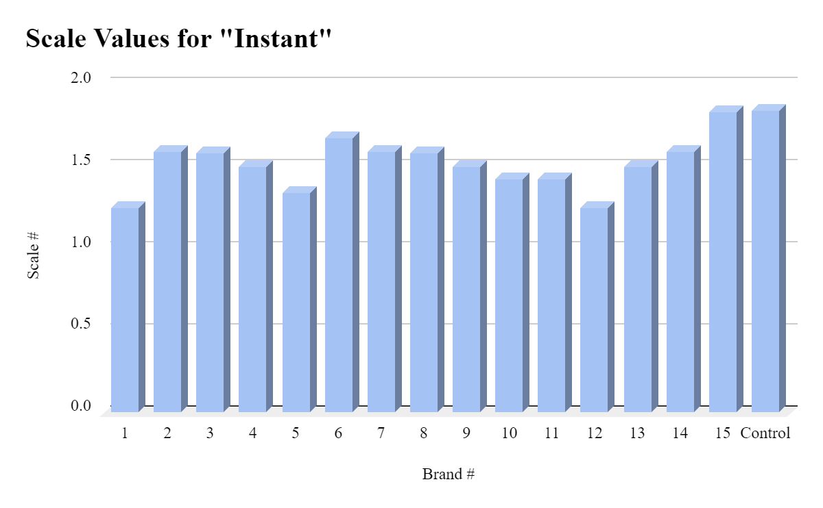
10 Seconds
Brand | Scale #
1 (Coppertone Tanning Sunscreen Lotion)  - SPF 15, Chemical | 1.67
2 (Neutrogena Ultra Sheer)  - SPF 30, Chemical | 2.09
3 (Neutrogena Sheer Zinc)  - SPF 50, Mineral | 2.34
4 (Neutrogena Ultra Sheer)  - SPF 55, Chemical | 2.17
5 (Neutrogena Ultra Sheer)  - SPF 70, Chemical | 2.17
6 (Coppertone Pure & Simple Baby Sunscreen Lotion)  - SPF 50, Mineral | 2.25
7 (Ultrasun Professional Protection Face)  - SPF 50+, Unidentified | 1.92
8 (Skinceuticals Physical Fusion)  - SPF 50, Mineral | 2.42
9 (Sun Bum)  - SPF 50, Chemical | 2.08
10 (Lamer UV Protecting Fluid)  - SPF 50, Chemical | 2.09
11 (Coppertone Kids Tear Free Sunscreen Lotion)  - SPF 50, Combination | 2.17
12 (Banana Boat Sport Ultra Spray)  - SPF 50+, Chemical | 2.09
13 (Ultrasun Professional Protection Face)  - SPF 30, Unidentified | 2.25
14 (Sun Bum)  - SPF 30, Chemical | 2.25
15 (Tatcha Silken Pore Perfecting Sunscreen)  - SPF 35, Combination | 1.83
Control (Nothing) | 2.92
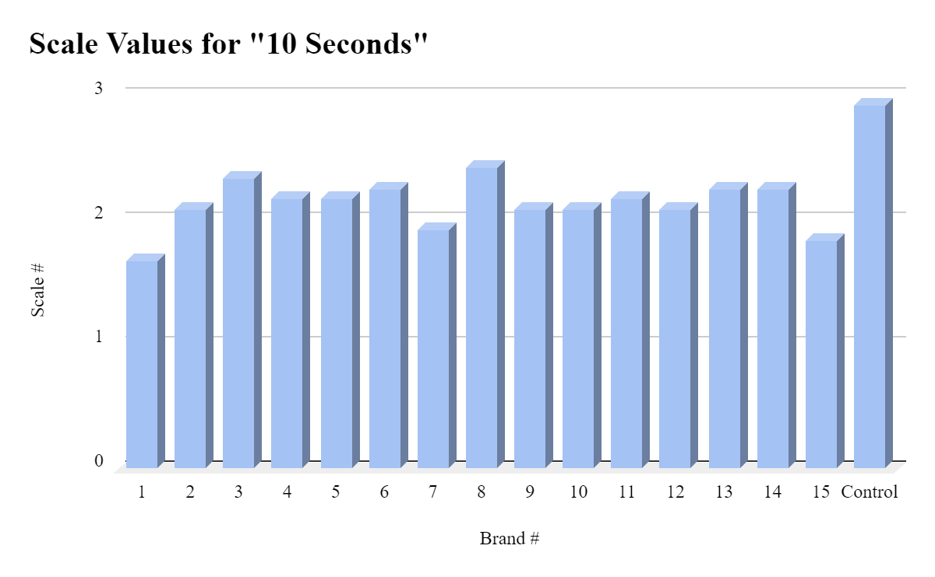
30 Seconds
Brand | Scale #
1 (Coppertone Tanning Sunscreen Lotion)  - SPF 15, Chemical | 2.25
2 (Neutrogena Ultra Sheer)  - SPF 30, Chemical | 2.5
3 (Neutrogena Sheer Zinc)  - SPF 50, Mineral | 2.75
4 (Neutrogena Ultra Sheer)  - SPF 55, Chemical | 2.75
5 (Neutrogena Ultra Sheer)  - SPF 70, Chemical | 2.67
6 (Coppertone Pure & Simple Baby Sunscreen Lotion)  - SPF 50, Mineral | 2.5
7 (Ultrasun Professional Protection Face)  - SPF 50+, Unidentified | 2.42
8 (Skinceuticals Physical Fusion)  - SPF 50, Mineral | 2.75
9 (Sun Bum)  - SPF 50, Chemical | 2.34
10 (Lamer UV Protecting Fluid)  - SPF 50, Chemical | 2.34
11 (Coppertone Kids Tear Free Sunscreen Lotion)  - SPF 50, Combination | 2.33
12 (Banana Boat Sport Ultra Spray)  - SPF 50+, Chemical | 2.5
13 (Ultrasun Professional Protection Face)  - SPF 30, Unidentified | 2.34
14 (Sun Bum)  - SPF 30, Chemical | 2.34
15 (Tatcha Silken Pore Perfecting Sunscreen)  - SPF 35, Combination | 2.58
Control (Nothing) | 3.17
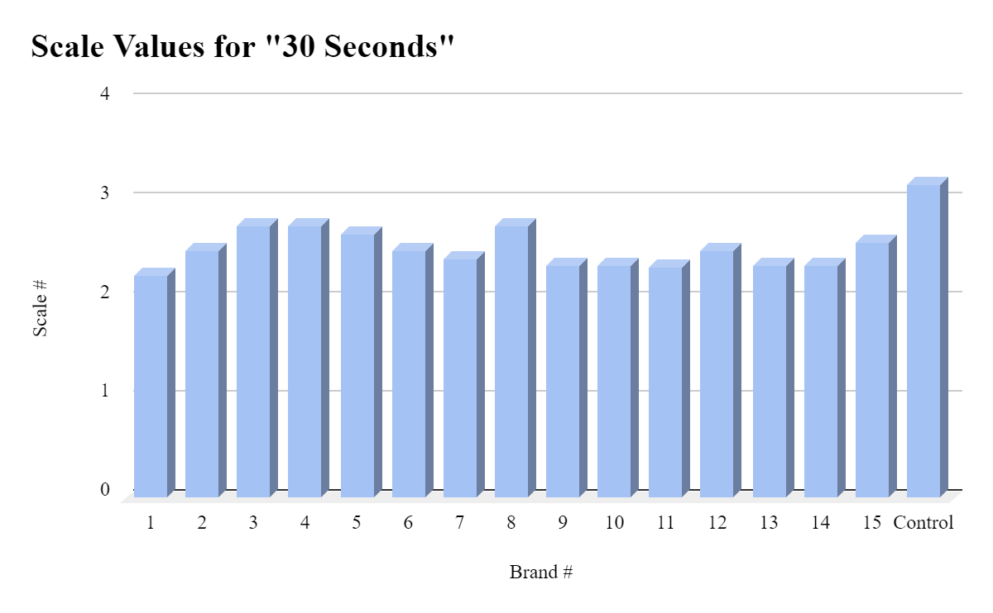
1 minute
Brand | Scale #
1 (Coppertone Tanning Sunscreen Lotion)  - SPF 15, Chemical | 2.67
2 (Neutrogena Ultra Sheer)  - SPF 30, Chemical | 2.67
3 (Neutrogena Sheer Zinc)  - SPF 50, Mineral | 3
4 (Neutrogena Ultra Sheer)  - SPF 55, Chemical | 2.75
5 (Neutrogena Ultra Sheer)  - SPF 70, Chemical | 3
6 (Coppertone Pure & Simple Baby Sunscreen Lotion)  - SPF 50, Mineral | 2.67
7 (Ultrasun Professional Protection Face)  - SPF 50+, Unidentified | 2.5
8 (Skinceuticals Physical Fusion)  - SPF 50, Mineral | 3
9 (Sun Bum)  - SPF 50, Chemical | 2.5
10 (Lamer UV Protecting Fluid)  - SPF 50, Chemical | 2.5
11 (Coppertone Kids Tear Free Sunscreen Lotion)  - SPF 50, Combination | 2.67
12 (Banana Boat Sport Ultra Spray)  - SPF 50+, Chemical | 2.84
13 (Ultrasun Professional Protection Face)  - SPF 30, Unidentified | 2
14 (Sun Bum)  - SPF 30, Chemical | 2.58
15 (Tatcha Silken Pore Perfecting Sunscreen)  - SPF 35, Combination | 2.5
Control (Nothing) | 3.42
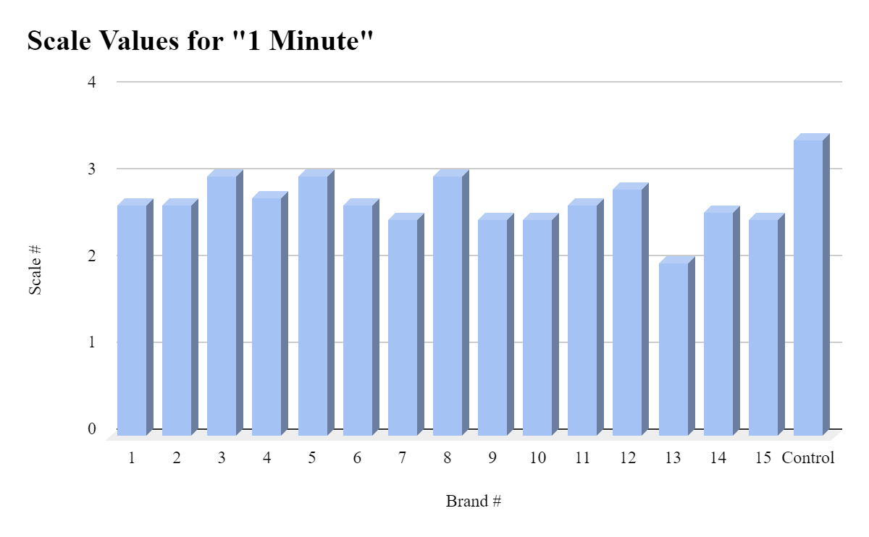
3 minutes
Brand | Scale #
1 (Coppertone Tanning Sunscreen Lotion)  - SPF 15, Chemical | 2.67
2 (Neutrogena Ultra Sheer)  - SPF 30, Chemical | 2.75
3 (Neutrogena Sheer Zinc)  - SPF 50, Mineral | 3.17
4 (Neutrogena Ultra Sheer)  - SPF 55, Chemical | 3
5 (Neutrogena Ultra Sheer)  - SPF 70, Chemical | 3
6 (Coppertone Pure & Simple Baby Sunscreen Lotion)  - SPF 50, Mineral | 2.83
7 (Ultrasun Professional Protection Face)  - SPF 50+, Unidentified | 2.67
8 (Skinceuticals Physical Fusion)  - SPF 50, Mineral | 3.17
9 (Sun Bum)  - SPF 50, Chemical | 2.67
10 (Lamer UV Protecting Fluid)  - SPF 50, Chemical | 2.67
11 (Coppertone Kids Tear Free Sunscreen Lotion)  - SPF 50, Combination | 2.75
12 (Banana Boat Sport Ultra Spray)  - SPF 50+, Chemical | 3
13 (Ultrasun Professional Protection Face)  - SPF 30, Unidentified | 2.75
14 (Sun Bum)  - SPF 30, Chemical | 2.67
15 (Tatcha Silken Pore Perfecting Sunscreen)  - SPF 35, Combination | 3.08
Control (Nothing) | 3.5
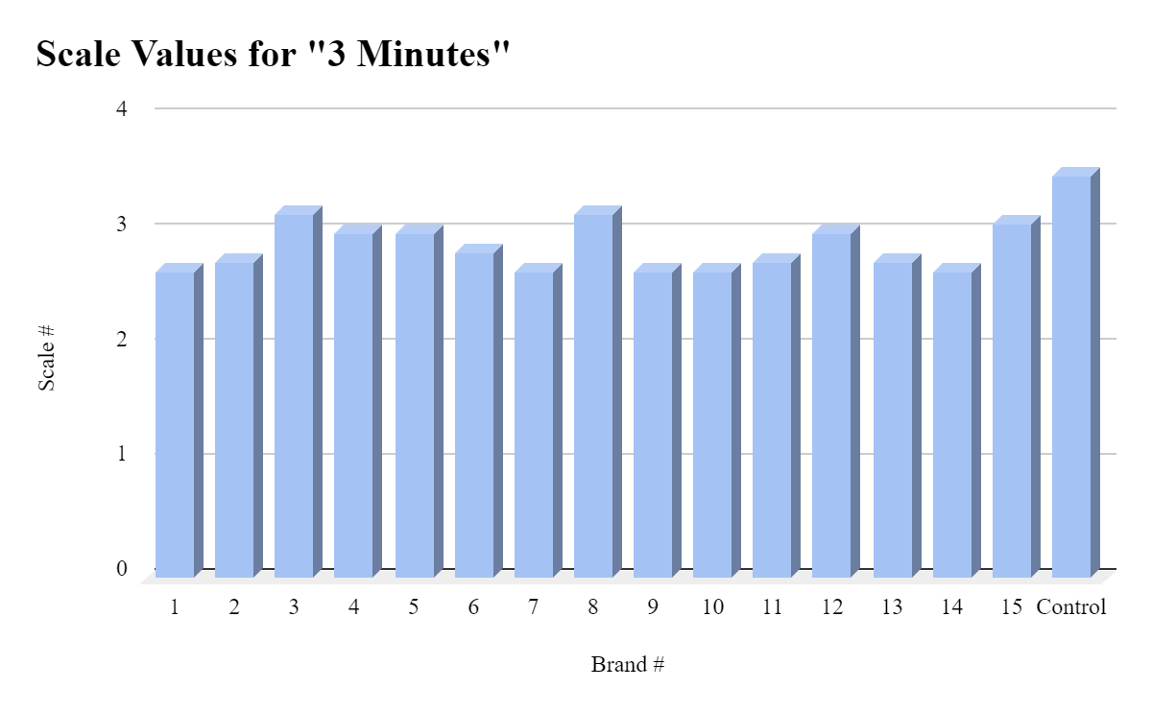
5 minutes
Brand | Scale #
1 (Coppertone Tanning Sunscreen Lotion)  - SPF 15, Chemical | 2.42
2 (Neutrogena Ultra Sheer)  - SPF 30, Chemical | 2.92
3 (Neutrogena Sheer Zinc)  - SPF 50, Mineral | 3.25
4 (Neutrogena Ultra Sheer)  - SPF 55, Chemical | 3.09
5 (Neutrogena Ultra Sheer)  - SPF 70, Chemical | 3
6 (Coppertone Pure & Simple Baby Sunscreen Lotion)  - SPF 50, Mineral | 2.92
7 (Ultrasun Professional Protection Face)  - SPF 50+, Unidentified | 2.75
8 (Skinceuticals Physical Fusion)  - SPF 50, Mineral | 3.25
9 (Sun Bum)  - SPF 50, Chemical | 2.83
10 (Lamer UV Protecting Fluid)  - SPF 50, Chemical | 2.83
11 (Coppertone Kids Tear Free Sunscreen Lotion)  - SPF 50, Combination | 2.84
12 (Banana Boat Sport Ultra Spray)  - SPF 50+, Chemical | 2.92
13 (Ultrasun Professional Protection Face)  - SPF 30, Unidentified | 2.58
14 (Sun Bum)  - SPF 30, Chemical | 3.17
15 (Tatcha Silken Pore Perfecting Sunscreen)  - SPF 35, Combination | 3
Control (Nothing) | 3.67
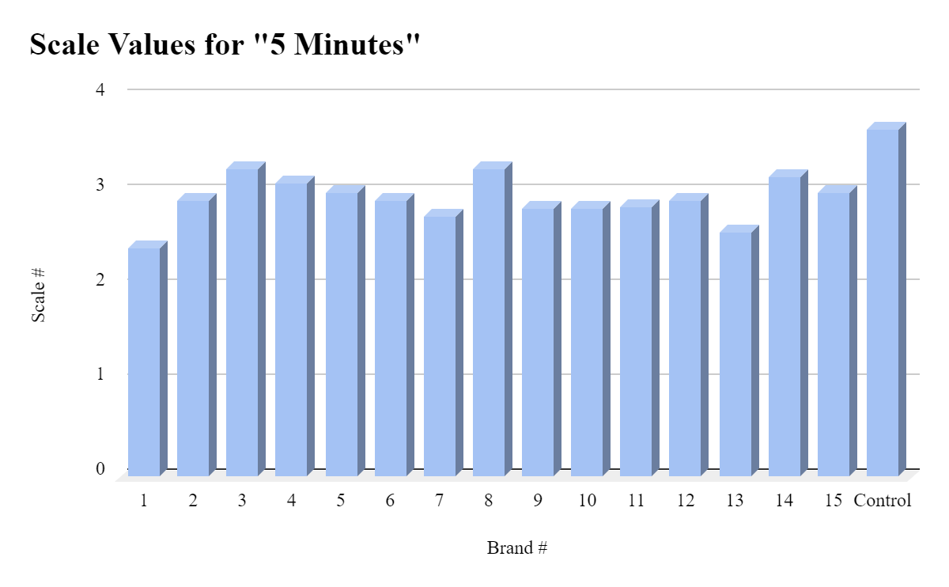

H: ANALYSIS

Outcomes and Discoveries:
- It is difficult to determine whether the SPF truly correlates to the protection based on this experiment alone. Surprisingly, number 1 performed very well, despite it having the lowest SPF out of every sunscreen. Numbers 1 and 7 were the most notable in producing the lightest colors in general. Numbers 8 and 3 were the most notable in producing the darkest colors. 2, 3, 6, 7, 11, 13, 14, and 15 were all quite successful in trial 3, where the most sunscreen was applied. All of these numbers scored constant 1s with their lightest hues from Instant all the way to 5 minutes. 3, 4, 6, 14, and 15 were the numbers that all reached the highest number on our scale, 5. The majority of these scores can be found at the 5 minute mark. I’m not exactly sure why some of these results were the way they were, however I assume they were most likely faults with the method I had used. These cards cannot accurately represent real human skin and how well a sunscreen can protect against the sun. An idea I had on why number 1 specifically performed so well is that it did not work on the card as it actually would on skin. Chemical sunscreens are absorbed into the skin, which is the primary way in which they protect the skin from UV rays. However, on the cards, the chemical sunscreens may not have been able to be absorbed, which only created a layer of sunscreen on top. This would not be an accurate representation of how chemical sunscreen works on the skin, since the sunscreen does not sit on top of your skin when applied, but it is absorbed into the skin.
- Notable for Instant:
- Lowest/lightest colors: 1, 12, 5
- Highest/darkest colors (NOT including control): 15, 6, 7 & 14 & 2
- Notable for 10 seconds
- Lowest/lightest colors: 1, 7, 15
- Highest/darkest colors (NOT including control): 3, 8, 6 & 13 & 14
- Notable for 30 seconds
- Lowest/lightest colors: 1, 11, 9 & 10 & 13 & 14
- Highest/darkest colors (NOT including control): 3, 4, 8
- Notable for 1 minute
- Lowest/lightest colors: 13, 7 & 9 & 10
- Highest/darkest colors (NOT including control): 3, 5, 8
- Notable for 3 minutes
- Lowest/lightest colors: 1 & 7 & 9 & 10 & 14
- Highest/darkest colors (NOT including control): 3, 8, 15
- Notable for 5 minutes
- Lowest/lightest colors: 1, 13, 7
- Highest/darkest colors (NOT including control): 3, 8, 4
- Number 8 was constantly shown for having some of the darkest colors. Something to note is that number 8 was the only sunscreen that was tinted. While every other sunscreen was white or clear, number eight was a tannish brown color, which may have affected the color perception. Since this test was determining the amount of protection a sunscreen provides by color alone, it may have been a bit disproving for this particular sunscreen.
- Chemical sunscreens that were thicker were typically more consistent. Number 12, which was the only spray, was also notably very consistent, with the largest difference between the darkest and lightest value only being 1.5, and the greatest difference between multiple trials 1. Sprays are not as affected by human error or inconsistency, which is why it was a very constant, clear color. Number 12 was also quite an outlier in this sense, due to the fact that it was the only spray. Although it was very consistent, it was also more difficult to apply more of. When you apply more and more spray, it just clumps up as a liquid.
- The amount of time the cards were exposed to the sun also had a clear difference. However, when you layer the sunscreen thick enough, you can retain the state of little exposure. Of course, it is inconvenient and strange to apply sunscreen in extremely thick layers. In this regard, this experiment also enforces the importance of reapplying sunscreen. Instead of applying large amounts of sunscreen, remember to apply the recommended amount and constantly reapply.
- When I applied very little in trial 1, and then added larger amounts in trials 2 and 3, there were significant differences especially with the chemical sunscreens. In general, thicker layers of sunscreen provide more protection, and this was very clearly displayed with the chemical sunscreens, as well as the combination sunscreens. For example, number 6’s lightest hue dropped from 3.5 all the way to one (from trial 1 to trial 3). I think this is because the chemical sunscreens act physically as a barrier, and need more full and thick layers to be able to completely protect the skin. Chemical sunscreens are not hindered by the amount you apply as much, due to the fact that they are absorbed by the skin in the first place.
- Overall, using color to measure the amount of protection sunscreen can provide is not a bad method to measure it, but it is extremely flawed. Tinted sunscreens have a clear disadvantage, and the paper or card material does not truly replicate the human skin.

Mistakes and things in the Experiment to improve on:
- A majority of the experimentation relied on the judgement of the person running the experiment, aka by human perception. For example, it was by my judgement to attempt to find the most noticeable dark hue and the most noticeable light hue.
- A problem that I encountered was that due to the fact that the tray I had was slightly indented, there was a shadow cast over a few of the cards, making the color most likely inaccurate from the true color. It made the colors seem very dull and grayish in the photos I had taken, when in real life, they were not.
- I attempted to apply the same amount of sunscreen for each one, however some sunscreens may have recommended amounts for application that differ from any other sunscreen. This may have given some sunscreens an advantage as their actual recommended amount was used, while some may not have been able to access how they are intended to be used.
- The amount of sunlight and how the sunlight was shining could’ve made some cards look different in multiple pictures, and could’ve slightly distorted the true color of each one.
- Every color was determined off of photographs I had taken during the experiment, where many outside factors such as lighting and positioning would have altered the data.
- The method of using the darkest and lightest point may not have been the most accurate or efficient way, for the lightest or darkest hues themselves could have both been outliers of what the actual color was.

I: CONCLUSION

It is difficult to determine whether SPF truly matters in an experiment like this, however there are many sources with real, practical scenarios that prove the importance of SPF. There is no distinct difference between how well chemical and mineral sunscreens perform, however mineral sunscreens must be applied more thickly. Some things I would do to improve the experiment would first be to minimize the area for human error and outside factors. The cards I had used are reusable, and revert back to white after it is brought back to an environment without exposure to UV light. If I were to try this experiment again, I would also see how long each sunscreen would take to revert back to normal, or find a way to see how water resistant each sunscreen was. I would also search for a more efficient and accurate way to represent how it would work on actual skin.

