Student: Michael Wang

High School: Princeton international school of mathematics and science (PRISMS)

State: New Jersey

Country: USA

Mentors: Dr. Gwen Bleckner

Dr. Wenlin Huang

Dr. Shuo Tian

Dr. Wei Wang

Yiling Wan

A Novel Reconstruction and Expression of Endostatin with pDC316 Plasmid in Eukaryotic Cells

Abstract
Endostatin is one of the strongest endothelial cell inhibitory factors that has been found so far, however, endostatin protein is extremely unstable and difficult to prepare and apply. The goal of this research is to investigate a novel biotechnology method to reconstruct endostatin. Subcloning endostatin gene into pDC316 plasmid and transfect into human embryonic kidney 293T cells is proposed in this research.

Endostatin gene is amplified by polymerase chain reaction (PCR). Purified endostatin gene fragments were ligated to eukaryotic expression vector pDC316. The reconstructed plasmids were transformed into competent cells E. coli DH5α. Single and clear-edged bacteria are tested by bacterial PCR and electrophoresis. Plasmid was extracted from the positive bacteria and was sequenced for further confirmation. The endostatin containing plasmid was transfected into 293T cells, the expression of the target gene in the infected cells was detected by reverse transcription-polymerase chain reaction(RT-PCR) and gel electrophoresis.

The final product reconstructed by endostatin DNA with the pDC316 vector was confirmed by sequencing and endostatin mRNA was successfully expressed in transfected 293T cells. This research successfully reconstructed endostatin into pDC316 plasmid vector and transfected the identified plasmid into 293T cells. This recombinant endostatin has potential value angiogenesis gene therapy.

Keywords

Recombinant Endostatin, Angiogenesis, pDC316, 293T cells

Table of contents
Abstract……………………………………………………………………………….....p.2
Background……………………………………………………………………………...p.3
Methods……………………………………………………………………………….....p.4
Combine Endostatin fragment with pDC316 vector ………………...…. p.4
Extract the identified plasmid……………………….................................p.6
Detect the expression……………..………………………………………p.7
Results…………………………………………………………………………………...p.8
Discussion……………………………………………………………..…………..…...p.9
Conclusion……………………………………………………………………………..p.10
References……………………………………………………………………………...p.11
Acknowledgements……………………………………………………………...……..p.13
Declaration of Academic Integrity……………………………………………………..p.13

Background
More than 40 years ago, Judah Folkman published a revolutionary new way to think about tumor and shared his new hypothesis that tumor growth is angiogenesis dependent [1]. Angiogenesis is the physiological process that new blood vessels form from pre-existing blood vessels [2]. Over years, evidences are found to support Folkman’s idea and a new generation of research about angiogenesis has occurred [1]. In 1994, O’Reilly et al. discovered the first anti-angiogenic peptide named angiostatin, and since the discovery of angiostatin, other anti-angiogenic peptide with different collagen has been found [3]. Endostatin was first found in mouse cells in 1997 also by O’Reilly’s group and was subsequently found in humans [4]. The discovery of endostatin was a breakthrough to human on the understanding of angiogenesis [3].

Endostatin is a 20-kDa fragment located at the C-terminal of the noncollagenous (NC1) domain of the type XVIII collagen and it occurs as a globular protein in humans [3,5]. Under normal human physiological circumstances, angiogenesis is highly controlled by some chemical signals in the body such as vascular endothelial growth factor (VEGF) [6]. Endostatin can specifically inhibit the proliferation of vascular endothelial cells treated with basic fibroblast growth factor (bFGF) and induce endothelial cell apoptosis [4].
Uncontrolled angiogenesis would lead to pathological hyperplasia and neoplastic diseases [7,8]. It has been established that tumor growth and cancer depends on angiogenesis [9]. A variety of experiments can confirm that endostatin has an inhibitory effect on growing blood vessels, but has no effect on resting blood vessels, which can effectively limit uncontrolled angiogenesis [1]. The inhibitory effect of endostatin on angiogenesis is very important because of its potential as a cancer treating agent.

In recent years, there have been more and more researches that focus on endostatin anti-tumor angiogenesis therapy. The production of recombinant endostatin is difficult and it requires a large scale, therefore, different expression systems that aimed in recombinant endostatin production have been discovered and used in different studies. Those expression systems that involved in recombinant endostatin production includes: E. coli expression system, yeast expression system, and mammalian cell expression system [10,11]. E. coli expression system have a high expression level, but the products mostly exist in the form of insoluble inclusion bodies, causing inconvenience in the application [12]. Although the protein is soluble after refolding, a large amount of protein will be lost during this process. The expression product of mammalian cells has high biological activity, but low expression level, which is also difficult to purify [13]. Although the yeast expression system has high yield and is easy to purify compared to the other two [14], the transduction of the endostatin gene through an appropriate vector is a more concise method because of its strong capacity and efficiency. The endostatin gene is delivered by an appropriate vector to make it a long-term and stable expression of endostatin in the body, which can make up for the deficiency of protein therapy. It has been confirmed that liposomes, adenovirus, retrovirus, adeno-associated virus, and lentivirus are all effective vectors [15]. Compared with non-viral vectors, higher plasma concentrations of endostatin will be obtained after transfection with viral vectors.

In this study, I propose to reconstruct endostatin by using pDC316 plasmid and transfect the product into human embryonic kidney 293T cells. RT-PCR and electrophoresis was used to confirm the production of correct RNA in 293T cells.

Method
Combine Endostatin fragment with pDC316 vector
The Endostatin segment was amplified by using polymerase chain reaction. The 50ul reaction system includes: water 33.7ul, dNTP 5ul, 5x KOD buffer 5 ul, both F and R primer 1.5ul, endostatin cDNA template 0.3ul, KOD enzyme 1ul, and MgSO4 solvent 2ul.

The sequence of the forward primer is 5’CGGGATCCATGGCCCACAGCCACCGGG and the sequence of the reverse primer is 5’CCCAAGCTTTCACTTGGAGGCTGTCATAAAGC (Table 1). The PCR conditions were designed as follows: initial denaturation at 94°C for 2 minutes, 35 cycles of 98°C for 10 seconds, 60°C for 30 seconds and 68°C for 55 sec followed by final extension at 68°C for 2 min (Table 2).
Name | Sequence | number of bases | OD  /tube | Nmol/  tube | water added (μl)
he10a_F_B1 | 5’CGGGATCCATGGCCCACAGCCACCGGG3’ | 27 | 2 | 7.99 | 79.9
he10A_R_H3 | 5’CCCAAGCTTTCACTTGGAGGCTGTCATAAAGC3’ | 32 | 2 | 6.74 | 67.4
Table 1. Details of both primers

Step | 1 | 2 | 3 | 4 | 5
Temperature(°C) | 94 | 98 | 60 | 68 | 68
Time(min:sec) | 2:00 | 0:10 | 0:30 | 0:55 | 2:00
Go to | 0 | 0 | 0 | 2 | 0
Cycle | 0 | 0 | 0 | 35 | 0

Table 2. PCR conditions

After PCR was completed, the sample were electrophoresed by adding the DNA loading buffer with the ratio of 5:1. A marker(1x) for comparison was also added in the gel (Fig 1). The gel runs for 20 min under 150V. The same type of marker and the same gel setting is also used for the rest of gel electrophoresis through the whole study.
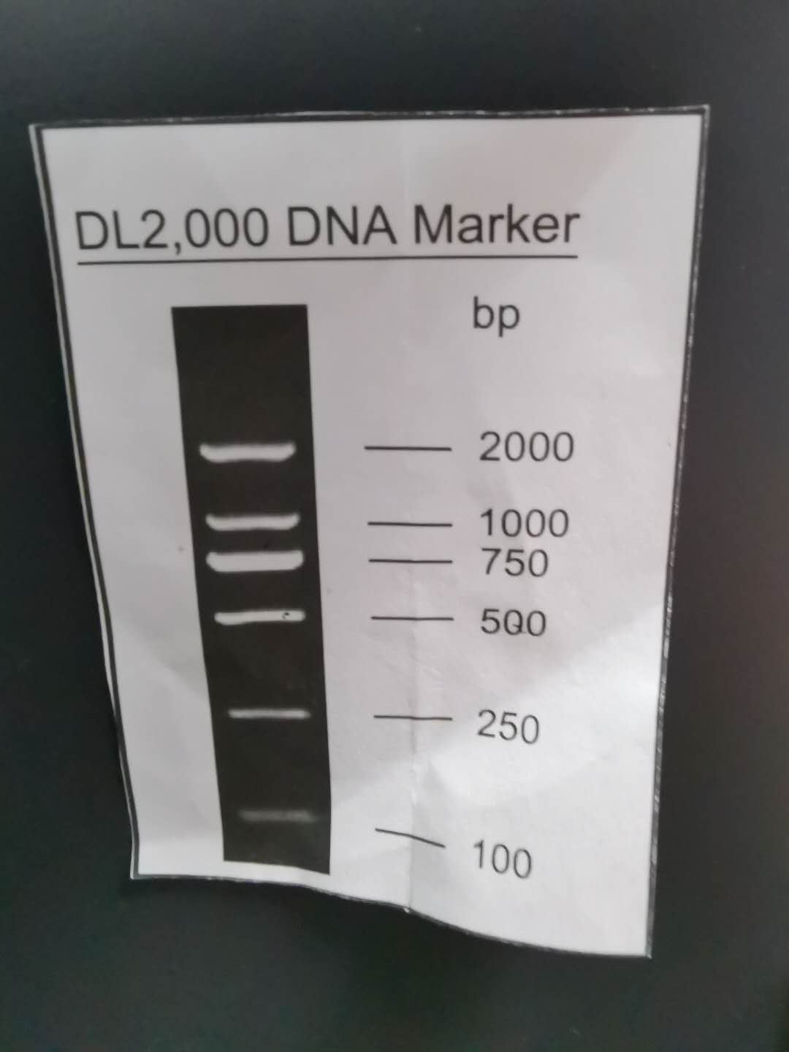

Figure 1. The marker

After the electrophoresis was completed, gel extraction was performed by using E.Z.N.A Gel Extraction Kit (OMEGA) in order to obtain a pure, single PCR product and gene ladder. Next, HindIII and BamH I which are two type II restriction enzymes was used to digest the results from gel extraction. The 20ul reaction system includes: pDC316 vector or cDNA templates 10 ul, BamH I enzyme 1ul, Hind III enzyme 1 ul, CadSmart buffer 2ul, and water 6ul. In the process of enzyme digestion, the tube was put in a 37 °C water bath for 3 hours.

Those DNA segments were ligated to pDC316 plasmid (Fig 2) by adding t4 DNA ligase. The 20ul reaction system includes: water 15.3ul, DNA segments 1.4ul, pDC316 plasmid 0.3ul, t4 DNA ligase 1ul and t4 buffer 2ul. The mixture was incubated under room temperature for 3 hours.
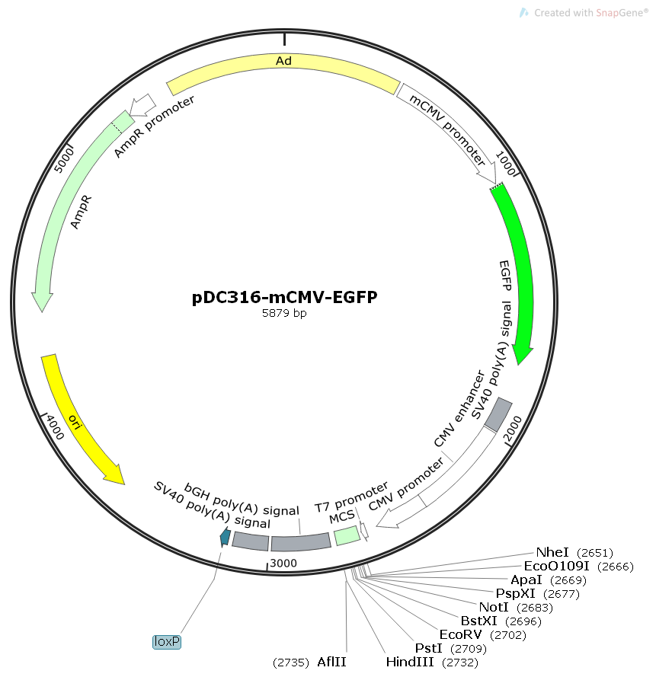

Figure 2. pDC316 plasmid

Extract the identified plasmid
The products produced by ligation are transformed into competent cells E. coli DH5α with the volume 10ul and 20ul respectively. During transformation, it needs to be iced for 30 minutes and then placed in a 42°C water bath for 60 seconds. The resulting mixture was transferred evenly onto a LB petri dish. The petri dish was incubated in a 37°C incubator for 16 hours.

Bacteria that showed single and clear-edged were selected from the petri dish after cultivation and run bacterial colony PCR by adding the same primers. The 20ul reaction system includes: water 5ul, Taq PCR master mix 10ul, both F and R primer 1ul,and bacteria template (made by 10ul water and a single bacteria) 3ul. The bacterial PCR conditions were designed as follows: Initial denaturation at 95°C for 3 minutes, 30 cycles of 94°C for 25 sec, 60°C for 25 sec and 72°C for 55 sec followed by final extension at 72°C for 3 min (Table 3).

Step | 1 | 2 | 3 | 4 | 5
Temperature(°C) | 95 | 94 | 60 | 72 | 72
Time(min:sec) | 3:00 | 0:25 | 0:25 | 0:55 | 3:00
Goto | 0 | 0 | 0 | 2 | 0
Cycle | 0 | 0 | 0 | 30 | 0

Table 3. Bacterial PCR conditions

After the bacterial PCR was completed, the sample was electrophoresed for checking if the sample contains the same ladder as the first gel electrophoresis showed. If the sample shows the same ladder, it can prove that the bacteria contains the identified plasmid. Select a single and clear-edged bacteria sample and add it into a 6ml liquid nutrition medium. Shake the tube on a shaker for 16 hours to mix the substances. The plasmids were collected by using E.Z.N.A endo-free plasmid extraction mini kit (OMEGA). The DNA sample was sent to Sangon Guangzhou for DNA sequencing.

Detect the expression
Plasmids were transfected into 293T cells following the PEI transfection protocol. Extract RNA from the cells by following the RNA extraction kit (CW bio). The expression of the target gene in the infected cells was detected by RT-PCR and electrophoresis. The 25ul reaction system includes: water 7.5ul, SuperRT onestep buffer 12.5ul, SuperRT onestep Enzyme Mix 0.5ul, both F and R primer 1ul,and RNA extracted from the cells 2.5ul. The RT-PCR conditions were designed as follows: Initial denaturation at 95°C for 2 minutes, 35 cycles of 94°C for 30 sec, 55°C for 30 sec and 72°C for 30 sec followed by final extension at 72°C for 5 min (Table 4).

Step | 1 | 2 | 3 | 4 | 5 | 6
Temperature(°C) | 45 | 95 | 94 | 55 | 72 | 72
Time(min:sec) | 30:00 | 2:00 | 0:30 | 0:30 | 0:30 | 5:00
Goto | 0 | 0 | 0 | 0 | 3 | 0
Cycle | 0 | 0 | 0 | 0 | 35 | 0

Table 4. RT-PCR conditions

After RT-PCR, run Agarose gel electrophoresis for identification. 10 ul of the processed RNA sample was sent to Sangon Guangzhou for DNA sequencing and confirming the result.

Results
Fig 3 shows the DNA ladder that showed after the first gel electrophoresis. The DNA ladder of endostatin is shown on the left and the marker is shown on the right. By comparing the DNA ladder of endostatin to the ladders showed by the marker, the DNA ladder of endostatin is approximately a bit more than 500bp.

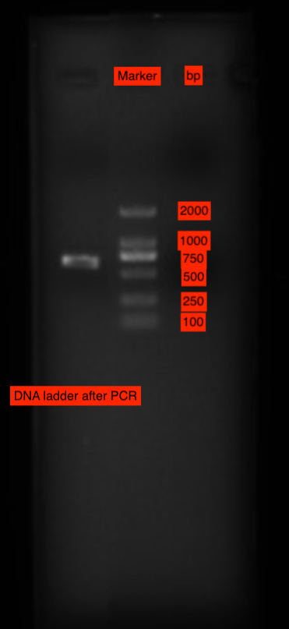

Figure 3. DNA ladder of endostatin(left) and the marker(right) after PCR

The DNA sequence of extracted bacterial plasmid was sequenced by Sangon Guangzhou and was compared to the corresponding correct gene sequences by Snapgene and there is no difference. Therefore, the extracted bacterial plasmid is correct.

The RNA produced by transfected 293T cells was reverse translated by the RT-PCR process using superRT one step RT-PCR kit. Fig 4 shows the DNA ladder that showed after the agarose gel electrophoresis and RT-PCR. As shown in Fig 4, the first column shows the ladder of the marker and the rest of them are the ladder of the product DNA (four samples in order to make sure the result is correct). They are all approximately more than 500 bp which is the same as the result of the first gel electrophoresis. Therefore, the transfected 293T cells have successfully expressed endostatin.
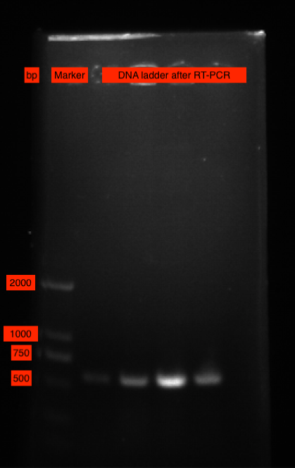

Figure 4. DNA ladder showed in the gel electrophoresis after RT-PCR.

The DNA sequence of reverse translated RNA from transfected 293T cells was sequenced by Sangon Guangzhou and was compared to the corresponding correct gene sequences by Snapgene and there is no significant difference. Therefore, the RNA produced by 293T cells was correct and the reconstruction of endostatin was successful.

Discussion
pDC316 is an E1 shuttle plasmid, derived from the left end of the adenovirus type 5 (AD5) genome, which contains human cytomegalovirus immediate early promoter, a polycloning site, and simian virus 40 (SV40) polyadenylation signals [16]. The plasmid pDC316 is very versatile, with both eukaryotic and prokaryotic shuttle capability and with both prokaryotic and eukaryotic cell promoter originals. Also, pDC316 has two antibiotics genes which is easy for expansion. Last but lost least, pDC316 has a large capacity and can carry large fragments genes. Using the advantages of pDC316, this study successfully reconstructed endostatin into pDC316 plasmid vector and transfected the identified plasmid into 293T cells, which correctly expresses endostatin mRNA.

There are several parts that can be improved in this experiment. After RT-PCR, the protein expression in infected cells should be further confirmed by Western blotting. Western blotting is a useful technique that combines high efficiency gel electrophoresis and immunochemical analysis. Western blotting has the advantages of high sensitivity, large analysis capacity, and high efficiency. In nowadays, western blot is one of the most commonly used methods for detecting protein expression and distribution [17].

For future experiments, the most important thing that can be done is to use Adenovirus type 5(AD5) to package the reconstructed plasmid. Adenovirus is currently one of the most stable, reliable and efficient recombinant virus. It has the following advantages: 1. Wide host range. Adenovirus can infect a range of mammalian cells and it is highly compatible with 293 cells including 293T cells. 2. Because the infection of adenovirus does not depend on the cell cycle, it can infect both proliferating cells and non-proliferating cells. 3. Adenovirus has the characteristics of epithelial cells, because most tumor cells are epithelial cells, which makes adenovirus very suitable for the field of gene therapy. 4. It is strongly immunogenic [18,19]. After packaging the recombinant endostatin with adenovirus, it can be used to infect certain cells from the human body, such as vascular endothelial cells, which is important for further studies on human.

Using AD5 adenovirus for package will also highly combines with the recombinant endostatin because pDC316 plasmid is derived from the AD5 genome. Combining the advantages of pDC316 plasmid and AD5 for packaging, the result is likely to be helpful in the use of endostatin in humans.

Conclusion
In mice, recombinant endostatin has shown significant inhibitory activity against a wide range of tumors. The human form of endostatin has also been produced in a recombinant form and exhibits antiangiogenic activity [20], which proves endostatin’s potential value in future clinical application. Nowadays, several drugs related to recombinant endostatin are in the pipeline at different stages of clinical trials. It can be expected that more antiangiogenic drugs related to recombinant endostatin will become available for patients in the near future [21].

In final conclusion, this study successfully reconstructed endostatin into pDC316 plasmid vector and transfected the identified plasmid into 293T cells, which correctly expresses endostatin mRNA. The final product would have potential value in clinical trials and angiogenesis gene therapy.

References
- Ribatti D. (2008). Judah Folkman, a pioneer in the study of angiogenesis. Angiogenesis, 11(1), 3–10. https://doi.org/10.1007/s10456-008-9092-6
- Wikipedia contributors. (2020, July 4). Angiogenesis. In Wikipedia, The Free Encyclopedia. Retrieved 14:01, September 4, 2020, from https://en.wikipedia.org/w/index.php?title=Angiogenesis&oldid=965958178
- Walia, A., Yang, J. F., Huang, Y. H., Rosenblatt, M. I., Chang, J. H., & Azar, D. T. (2015). Endostatin's emerging roles in angiogenesis, lymphangiogenesis, disease, and clinical applications. Biochimica et biophysica acta, 1850(12), 2422–2438. https://doi.org/10.1016/j.bbagen.2015.09.007
- Wikipedia contributors. (2020, April 15). Endostatin. In Wikipedia, The Free Encyclopedia. Retrieved 13:26, September 4, 2020, from https://en.wikipedia.org/w/index.php?title=Endostatin&oldid=951078398
- Javaherian, K., Lee, T. Y., Tjin Tham Sjin, R. M., Parris, G. E., & Hlatky, L. (2011). Two Endogenous Antiangiogenic Inhibitors, Endostatin and Angiostatin, Demonstrate Biphasic Curves in their Antitumor Profiles. Dose-response : a publication of International Hormesis Society, 9(3), 369–376. https://doi.org/10.2203/dose-response.10-020.Javaherian
- Rajabi, M., & Mousa, S. A. (2017). The Role of Angiogenesis in Cancer Treatment. Biomedicines, 5(2), 34. https://doi.org/10.3390/biomedicines5020034
- Yoo, S. Y., & Kwon, S. M. (2013). Angiogenesis and its therapeutic opportunities. Mediators of inflammation, 2013, 127170. https://doi.org/10.1155/2013/127170
- Gupta, K., & Zhang, J. (2005). Angiogenesis: a curse or cure?. Postgraduate medical journal, 81(954), 236–242. https://doi.org/10.1136/pgmj.2004.023309
- Nishida, N., Yano, H., Nishida, T., Kamura, T., & Kojiro, M. (2006). Angiogenesis in cancer. Vascular health and risk management, 2(3), 213–219. https://doi.org/10.2147/vhrm.2006.2.3.213
- Mohajeri, A., Sanaei, S., Kiafar, F., Fattahi, A., Khalili, M., & Zarghami, N. (2017). The Challenges of Recombinant Endostatin in Clinical Application: Focus on the Different Expression Systems and Molecular Bioengineering. Advanced pharmaceutical bulletin, 7(1), 21–34. https://doi.org/10.15171/apb.2017.004
- Mohajeri, A., Pilehvar-Soltanahmadi, Y., Pourhassan-Moghaddam, M., Abdolalizadeh, J., Karimi, P., & Zarghami, N. (2016). Cloning and Expression of Recombinant Human Endostatin in Periplasm of Escherichia coli Expression System. Advanced pharmaceutical bulletin, 6(2), 187–194. https://doi.org/10.15171/apb.2016.026
- Singh, A., Upadhyay, V., Upadhyay, A. K., Singh, S. M., & Panda, A. K. (2015). Protein recovery from inclusion bodies of Escherichia coli using mild solubilization process. Microbial cell factories, 14, 41. https://doi.org/10.1186/s12934-015-0222-8
- Gray D. (2001). Overview of protein expression by mammalian cells. Current protocols in protein science, Chapter 5(1), Unit5.9. https://doi.org/10.1002/0471140864.ps0509s10
- Vieira Gomes, A. M., Souza Carmo, T., Silva Carvalho, L., Mendonça Bahia, F., & Parachin, N. S. (2018). Comparison of Yeasts as Hosts for Recombinant Protein Production. Microorganisms, 6(2), 38. https://doi.org/10.3390/microorganisms6020038
- Li, L., Huang, J. L., Liu, Q. C., Wu, P. H., Liu, R. Y., Zeng, Y. X., & Huang, W. L. (2004). Endostatin gene therapy for liver cancer by a recombinant adenovirus delivery. World journal of gastroenterology, 10(13), 1867–1871. https://doi.org/10.3748/wjg.v10.i13.1867
- Winter L.E., Barenkamp S.J. Construction and immunogenicity of recombinant adenovirus vaccines expressing the HMW1, HMW2, or Hia adhesion protein of nontypeable Haemophilus influenzae. Clin Vaccine Immunol. 2010;17:1567–1575.
- Anderson, G. J., M Cipolla, C., & Kennedy, R. T. (2011). Western blotting using capillary electrophoresis. Analytical chemistry, 83(4), 1350–1355. https://doi.org/10.1021/ac102671n
- Lee, C. S., Bishop, E. S., Zhang, R., Yu, X., Farina, E. M., Yan, S., Zhao, C., Zheng, Z., Shu, Y., Wu, X., Lei, J., Li, Y., Zhang, W., Yang, C., Wu, K., Wu, Y., Ho, S., Athiviraham, A., Lee, M. J., Wolf, J. M., … He, T. C. (2017). Adenovirus-Mediated Gene Delivery: Potential Applications for Gene and Cell-Based Therapies in the New Era of Personalized Medicine. Genes & diseases, 4(2), 43–63. https://doi.org/10.1016/j.gendis.2017.04.001
- Wold, W. S., & Toth, K. (2013). Adenovirus vectors for gene therapy, vaccination and cancer gene therapy. Current gene therapy, 13(6), 421–433. https://doi.org/10.2174/1566523213666131125095046
- Andrew L. Feldman, Steven K. Libutti, in The Cytokine Handbook (Fourth Edition), 2003
- Zhen-Yu Ding, Yu-Quan Wei, in Recent Advances in Cancer Research and Therapy, 2012

Acknowledgements
Many thanks to Doublle Bioproduct Co. Ltd in Guangzhou for provided me with a perfect lab environment and good experimental equipment. Also, many thanks to Dr. Gwen Bleckner, Dr. Wenlin Huang, Dr. Shuo Tian, Dr. Wei Wang, and Yiling Wan who have helped me a lot in the study.

Declaration of Academic Integrity
I state that the submitted manuscript was the research work and results under the guidance of my mentors. I promise that, except for the reference, the paper does not contain results that other researchers have published.
I have read and understood the Institute’s regulations and procedures concerning plagiarism.
Signature: Michael Wang

